**VaR PREDICTION FOR GARCH MODEL (1,1) WITH NORMAL AND STUDENT-t ERROR DISTRIBUTION**

**Novi Permata Indah1*, Dian Permata Sari2, I Putu Eka Wijaya3, Madjidainun Rahma4**

1Management Study Program, Faculty of Economics, Singaperbangsa Karawang University, Indonesia

3Agribusiness Study Program, Faculty of Agriculture, Singaperbangsa Karawang University, Indonesia

4Accounting Study Program, Faculty of Economics, Singaperbangsa Karawang University, Indonesia

*Email: [novi.permata@fe.unsika.ac.id](mailto:novi.permata@fe.unsika.ac.id)

Diterima: xx bulan 2021. Disetujui: xx Bulan 2021. Dipublikasikan:xx bulan 2021

**Abstract:** This study aims at determining the estimated parameters of the GARCH model (1.1), establishing the prediction of the VaR value and defining the accuracy of the VaR prediction. In this study, the error in the GARCH model uses a normal distribution and student-t distribution. The research method focuses on parameter calculation and prediction of VaR value within 2 aspects regarding analytic and numeric. Analytically, it will be found the prediction of the VaR value and the accuracy of the prediction of the VaR value through the VaR coverage opportunity. It is very difficult to estimate the parameters for the GARCH model (1,1) analytically, thus, the parameters are estimated numerically using the Quansi Newton optimization method. Prediction of VaR value and VaR coverage probability will be simulated numerically by using stock return data of IBM, INDF.JK and GSPC. The results show that the GARCH model (1.1) can be used to model stock returns for IBM, INDF.JK and GSPC. There is no significant difference between the GARCH model (1,1) with a normally distributed error and GARCH (1,1) with a student-t distribution error in determining the prediction of VaR values. The numerical simulation results display that the prediction of the VaR value by using the GARCH model (1.1) with a normally distributed error is more accurate than the student-t-distributed error.

**Keywords :** *GARCH Model, Value at Risk, Coverage Probability*

**INTRODUCTION**

Nowadays, the stock market turns as one of the interesting research objects. The trigger of stock prices are used as a barometer of economic health in a country [3]. The stock market itself means that it is closely related to investment. The returns obtained by an investor in the stock market are known as asset returns. Asset return is the rate of return of an investment over a certain period of time [1]. According to Frances et al. (1987), Dennis and Sim (1999), Hull (2000) and Sherif and Ewing (2004) asset returns in various countries generally show the phenomenon of time varying volatility. This situation shows that there is a relatively 'calm' return period which then changes to a 'turbulent' period. Return behavior information is not enough to analyze financial time series data, consequently, the term of volatility appears. Volatility remains a measure of the spread of the magnitude of changes in the price of a financial instrument. In other words, volatility measures how much and how quickly the value of a financial instrument changes. Generally, the volatility of time series data is assumed to be constant over time. However, the volatility of financial time series data can change over a certain period. This change was caused by the reaction of the financial market to various kinds of disturbances, including deteriorating political conditions, economic crises, wars, natural disasters and others [10]. This results in the assumption that the volatility of the financial time series data is not constant.

Volatility modeling has an significant role in the financial sector, especially in risk management. According to Tsay (2005), volatility modeling can be used to calculate the maximum loss from an asset return that can be tolerated with a certain level of significance within a certain period. Based on Cont (2001) and Engle and Patton (2001) a good volatility model is a model that is able to accommodate the properties of asset returns and volatility. One of the good volatility models in modeling stock return volatility according to Bolerslev (1986) is the Generalized Autoregressive Conditionally Heteroscedastic (GARCH) model. This model states that volatility is an observable function and is determined by observations and the volatility of the previous time.

The loss towards return is related to a measure of risk. Through the GARCH volatility model, the risk of investment loss can be estimated and measured. One measure of risk that can be used in estimating the magnitude of risk in the GARCH model is Value at Risk (VaR). VaR is a measure of market risk that has been widely used for financial risk management, including in banking institutions, regulators and portfolio managers [11].

This research determines the predictive value of value at risk analytically and numerically. Numerical calculationsv displays the estimated parameter GARCH (1,1) with an error that is normally distributed and student-t. In addition, numerical calculations will define the prediction of the VaR value for the GARCH (1,1) model with normal and student-t distribution errors and the accuracy of the prediction through the correct VaR proportion.

**RESEARCH METHOD**

The risk of financial assets in the form of stock investments can be measured by using volatility. The risk itself is a form of investor loss when investing in the stock market. Volatility model is a way to predict volatility in the stock market. The GARCH (1.1) volatility model introduced by Bollerslev (1986) and the volatility variance model introduced by Engle & Bollerslev (1986) and Nelson (1991) can capture the volatility of the financial time series. Therefore, predictions of volatility models are needed to protect financial assets in the future (So & Yu, 2006). In this study, the focus is on how to find the parameter estimation of the GARCH model (1,1) that fits the definition given by Bolerslev.

The definition of Bollerslev (1986) For instance  is a stochastic process that states the return of asseston time t.  can be said following GARCH model (1.1) if:

 

with assupmtion:

1.  and the stationary condition 
2. ~ iid F(0,1)
3.  and  free each other.
4.  and  free each other.

This GARCH model (1,1) follows the Markov process where the return value at time *t* only depends on the return time value (t 1), thus the conditional expectation is *E*[*Yt*|*Yt−*1] = 0 and the conditional variance is *Var*[*Yt*|*Yt−*1] = *σ*2. If the values of *Yt−*1 and *σt−*1are known, the value of *σt* is a constant. It is shown that the distribution of *Yt*|*Yt−*1 is the same as the distribution of *εt* with a mean of zero and a variance of *σ*2 . Based on this, then we can determine the return value at risk of *Yt*+1 as follows:



The prediction of VaR is known if the random sample  is



Furthermore, to determine the accuracy of the VaR prediction obtained in equation (1), a VaR accuracy test is carried out by determining the coverage probability. This coverage opportunity is expected to be close to the given level of confidence. The probability of VaR coverage for return in the GARCH model (1,1) is

Rendering to So & Yu (2006), the accuracy of the VaR prediction in the GARCH model (1.1) that fits the data can also be seen from the correct VaR value. The model is assumed as fit with the data if





Where  turns a proportion from return over VaR predicition. The value from GARCH parameter model (1,1) is  can be measured through likelihood maximum method. The estimation of the parameter values of the GARCH model (1,1) in this study was carried out only numerically, because analytically it is very difficult to determine the value of . The estimation value of numerically done with Quasi Newton optimization method.

The numerical simulation was carried out by using the MATLAB programming language. The data used in the numerical simulation is stock return data for International Business Machines Corporation (IBM.Inc), Indofood Sukses Makmur Tbk (INDF. JK), and the S&P 500 stock index ( GSPC). Data taken from January 4, 2010 to December 31, 2013.

**RESULT AND DISCUSSION**

The results of numerical data processing from the three stock return data of International Business Machines Corporation (IBM.Inc), Indofood Sukses Makmur Tbk (INDF. JK), and the S&P 500 stock index (GSPC) are presented in the following descriptive statistical table:

Table 1. Descriptive Statistics of Stock Return IBM, INDF.JK and GSPC

|  |  |  |  |  |  |  |
| --- | --- | --- | --- | --- | --- | --- |
| Stock | n | Mean | Variance | Skewness | Kurtosis | ACF(Lag 1) |
| IBM | 1006 | 3.4587 × 10−4 | 1.4295 × 10−4 | -0.6088 | 8.4349 | 0.0164 |
| INDF.JK | 1026 | 5.7068 × 10−4 | 4.2471 × 10−4 | -0.2697 | 6.7994 | 0.2015 |
| GSPC | 1006 | 4.8652 × 10−4 | 1.1443 × 10−4 | -0.4703 | 7.3579 | 0.2179 |

Table 1 shows that the three stocks have a negative skewness where the histogram data is skewed to the left. This shows that stock return data for IBM, INDF.JK and GSPC have relatively high values. The kurtosis value of the three stocks is greater than 3 so that the distribution is leptokurtic (thick tail). INDF.JK and GSPC stocks have a significant autocorrelation in the first lag compared to IBM stocks, meaning that today's return is quite influential on tomorrow. Of the three stocks, INDF.JK has the largest variance, meaning that it is quite risky to invest in INDF.JK shares compared to IBM and GSPC shares.

Furthermore, numerical calculations will determine the parameter estimation of the GARCH model (1,1) by using stock return data of INDF.JK, IBM and GSPC. The estimation results obtained can be seen in table 2.

Table 2. Estimation of Stock Return Model Parameters IBM, INJF.JK and GSPC

|  |  |  |  |  |  |
| --- | --- | --- | --- | --- | --- |
| Stock | Model |  |  |  |  |
| INDF.JK | GARCH(normal) | 0.0334× 10−4 | 0.1166 | 0.8522 |  |
|  | GARCH(t) | 0.0331 × 10−4 | 0.1248 | 0.8518 | 4.3311 |
| IBM | GARCH(normal) | 0.1962 × 10−4 | 0.1069 | 0.7615 | - |
| GARCH(t) | 0.0756 × 10−4 | 0.0648 | 0.8845 | 4.1655 |
| GSPC | GARCH(normal) | 0.2154 × 10−4 | 0.1101 | 0.8395 | - |
| GARCH(t) | 0.1977 × 10−4 | 0.1174 | 0.8480 | 5.1646 |

Table 2 shows that the stock of IBM, INDF.JK and GSPC have relatively small values. According to Alexander (2008), the value  in the GARCH model (1,1) shows the mean reversion speed (the tendency of returns to approach the average value from time to time). Based on the GARCH model with an error normal distribution or GARCH (normal) on GSPC stock, the fastest is reaching out the mean (4.8652 × 10−4). The coefficient  shows the magnitude of the influence of the previous time return value on today's return value, while the coefficient  shows the persistence of volatility. This means that the greater the value , the greater the volatility at the time  and so on. Thus, the volatility value from time to time tends to increase (there is persistence in volatility). According to Alexander (2008),  usually fluctuates around the value of 0.05 and the persistence coefficient  ranges from 0.85 to 0.98. In Table 2, the values  are relatively small,  relatively large, and .This shows that the GARCH model (1.1) with normally distributed error and student-t for the three stocks is a stationary model and persisten. If the value of , then the volatility of the model will increase indefinitely from time to time. This is very rarely the case with financial data, so it must be 

The next stage, will determine the prediction of Value at Risk from the returns of the three stocks using the GARCH model (1.1) with a normal distribution error or GARCH (normal) and GARCH (1.1) with a student-t distribution error or abbreviated as GARCH ( t). The VaR prediction uses *α* = 99%, *α* = 95% and *α* = 90%.

Table 3. The Prediction of VaR Value IBM Stock, INNDF.JK Stock and GSPC Stock at Time t+1

|  |  |  |  |  |
| --- | --- | --- | --- | --- |
| Stock | Model |  |  |  |
| INDF.JK | GARCH(normal) | 0.0357 | 0.0253 | 0.0197 |
| GARCH(t) | 0.0414 | 0.0240 | 0.0174 |
| IBM | GARCH(normal) | 0.0249 | 0.0176 | 0.0137 |
| GARCH(t) | 0.0290 | 0.0167 | 0.0120 |
| GSPC | GARCH(normal) | 0.0153 | 0.0108 | 0.0084 |
| GARCH(t) | 0.0173 | 0.0104 | 0.0077 |

It can be seen that the difference in VaR predictions between the GARCH(normal) and GARCH (t) models is quite small, namely ±10−3. This shows that the difference between the two volatility models is not significant in determining the VaR value. The VaR predictions for IBM, INDF.JK and GSPC stocks at time 1, ..., T can be seen in Figure 1, Figure 2 and Figure 3.

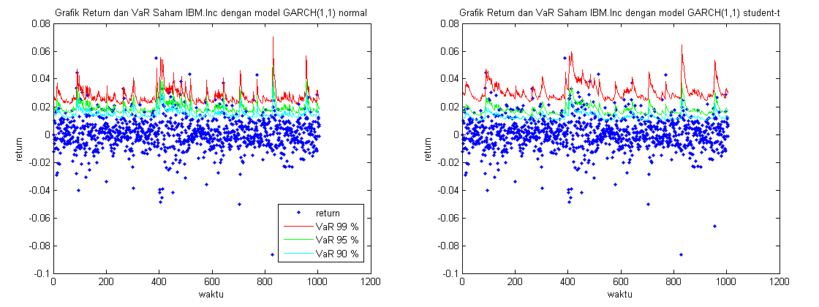

Figure 1. The Prediction of VaR Value of IBM Stock

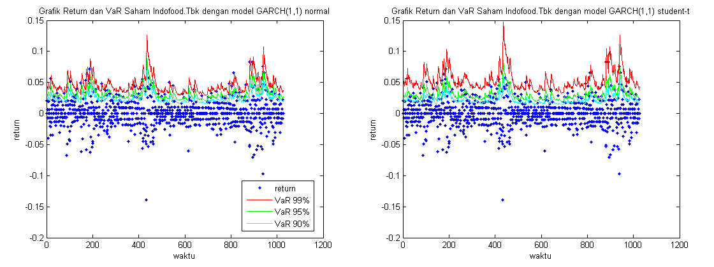

Figure 2. The Prediction of VaR Value of INDF.JK Stock

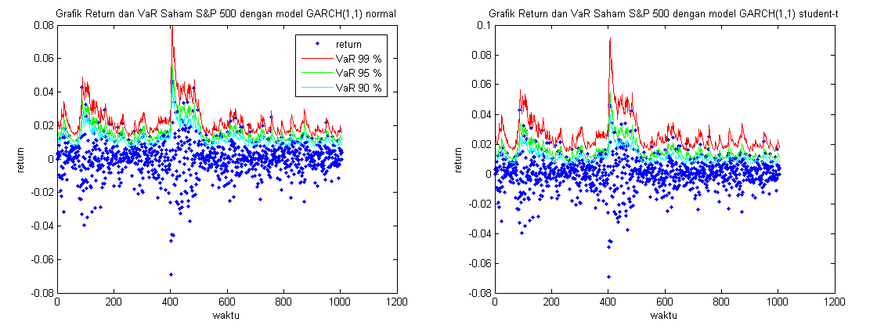

Figure 3. The prediction of VaR stock value of GSPC

Table 4. Correct VaR from IBM, INDF.JK and GSPC

|  |  |  |  |  |
| --- | --- | --- | --- | --- |
| Stock | Model | Correct VaR | | |
| 99 % | 95 % | 90 % |
| INDF.JK | GARCH (normal) | 98.0% | 94.05% | 90.25% |
| GARCH(t) | 98.8% | 93.86% | 88.59% |
| IBM | GARCH (normal) | 98.9% | 95.43% | 92.05% |
| GARCH(t) | 99.1% | 94.33% | 89.36% |
| GSPC | GARCH (normal) | 98.6% | 95.03% | 90.85% |
| GARCH(t) | 99.5% | 94.73% | 89.07% |

According to Wong et al (2003), the accuracy of the value at risk (VaR) prediction can be known through the correct VaR proportion. Correct VaR proportion is a method of determining VaR accuracy by looking at the actual loss proportion that is less than or equal to the VaR prediction. The correct VaR of the three stocks in this study can be seen in table 4.

According to So & Yu (2006), a good VaR estimation method can be determined from the correct VaR. If the difference between the correct VaR and the significance level (α) is the smallest, then the model has a good 'performance' in predicting future values. Based on table 4, it is found that INDF.JK stock with a significance level of 99% GARCH with a student-t error distribution is more suitable to describe INDF.JK stock returns than GARCH with a normal error distribution. Meanwhile, with a significance level of 95% and 90%, GARCH with a normal error distribution is more suitable than GARCH with a student-t error distribution. In GSPC stocks, the model that best fits the data is the GARCH(1,1) model with the error being normally distributed.

**CONCLUTION**

Based on the research results, it is found that the GARCH (1,1) model can be used to model the stock returns of IBM, INDF.JK and GSPC. There is no significant difference between the GARCH (1,1) model with a normally distributed error and GARCH (1,1) with a student-t distribution error in determining the prediction of VaR values. It is known from the difference between the predictions of the two models which is quite small, only ±10−3. The predictive accuracy of the Value at Risk value can be determined by determining the correct VaR proportion. The simulation results of the three stocks in this study indicate that in general the prediction of Value at Risk using the GARCH model with a normally distributed error is more accurate than the GARCH model with a student-t distribution error.

Currently, there have been many developments from experts regarding the GARCH volatility model. Research can be continued by using these models, such as the integrated GARCH model, the stochatic GARCH and others.

**REFERENCES**

1. Alexander, C. (2008). *Pricing, Hedging and Tranding Financial Instrument*. Jhon Wiley and Sons.
2. Bollerslev, T. (1986). Generalized Autoregressive Conditional Heteroskedastic. *Journal of Econometrics*, *31*, 307–327.
3. Bursa Efek Indonesia. (2021). *Indeks, IDX*. <https://www.idx.co.id>
4. Cont, R. (2001). Empirical Properties of Asset Return: Stylized Facts and Statistical Issue. *Quantitative Finance*, *1*, 223–23.
5. Engle, R. F., & Bollerslev, T. (1986). Modeling The Persistence of Conditional Variance. *Econometric Riview*, *5*, 1–50.
6. Enggel, R. F., Patton, A.J. (2001). What Good is A Model?. *Quantitative Finance*, 1, 237-245.
7. Franses, P. H., Vanderleij, M., & Paap, R. (1987). Asimple Test for GARCH Against a Stochastic Volatility. *Journal of Financial Econometrics*, *6*, 291–301.
8. McNail, A.J., Frey, R., Embrechts, P. (2005). *Quantitative Risk Management*. United Kingdom: Princeton University Press.
9. Nelson, D. (1991). Conditional Heteroskedasticity in Asset return: a new approach. *Econometrica*, *59*, 347–370.
10. Posedel, P. (2005). Properties and Estimation of GARCH(1,1) Model. *Metodoloski Zvezki*, *2*, 243–257.
11. So, M. K. ., & Yu, P. L. (2006). Empirical Analysis of GARCH Models in Value at Risk Estimation. *Journal of International Financial Market Institution and Money*, *16*, 180–197.
12. Taylor, S.J. (2008). *Modeling Financial Time Series*. United States of America: Word Scientific Publising Co. Re. Ltd.
13. Tsay, R. . (2005). *Analysis of Financial Time Series*. John Wiley and Sons.